Early

Split 1

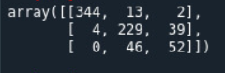

Split 2

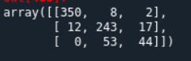

­Split 3

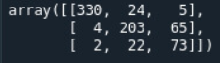

Split 4



Split 5

